
英语2024-2025学年六年级英语上学期期末全真模拟（人教精通版）
考试分数：100分 考试时间：60分钟
听力部分（满分：40分）
一、听句子或对话， 选出你所听到的单词，录音听两遍。（10分）
( ) 1. A．winter B．dinner C．after
( ) 2. A．easy B．eat C．every
( ) 3. A．month B．morning C．map
( ) 4. A．green B．clean C．spring
( ) 5. A．some B．spring C．seed
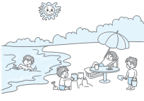
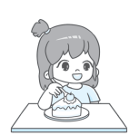

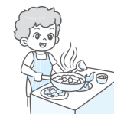
二、听句子， 判断下列图片与所听内容是（T）否（F）相符，录音听两遍。（10 分）

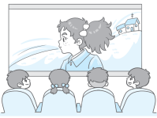

( ) ( ) ( ) ( ) ( )
三、听问句， 选择合适的答语，录音听两遍。（10分）
( ) 1. A．It‘s Sunday. B．It’s 6: 30. C．It's hot.
( ) 2. A．I’d like a bike. B．Yes, I’d love to. C．That’s OK.
( ) 3. A．It's on May 1st. B．It's on June 1st. C．It's on September 10th.
( ) 4. A．Very early. B．By bike. C．At 7: 30 am.
( ) 5. A.They make snowmen. B.They go swimming. C.They cut rice.
四、听短文， 补全空缺内容，每空一词，录音听两遍。（10分）
Han Mei likes Chinese New Year. She gets up early in the 1.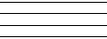 and 2. the 3. with her parents. They also buy all 4. of things for Chinese New Year. In the 5.
笔试部分（满分：60分）
五、判断下列每组单词画线部分的读音是（Y）否（N）相同。（10分）
( ) 1. play day bay
( ) 2. train tail plain
( ) 3. around should sound
( ) 4. old cold hold
( ) 5. grass green great
六、单项选择。（10分）
( ) 1. It’s spring now. It gets ______.
A．warmer B．hotter C．colder
( )2. ______ is before July but after May.
A．April B．June C．August
( ) 3. My grandma’s hobby is ______ Chinese tea.
A．drinking B．eating C．taking
( ) 4. Look! The students _____ the snow.
A. sweeps B．is sweeping C．are sweeping
( ) 5. Huahua will go to the party ______ August 1st.
A．at B. in C. on
七、判断下列句子或对话与图片是（T）否（F）相符。（10分）
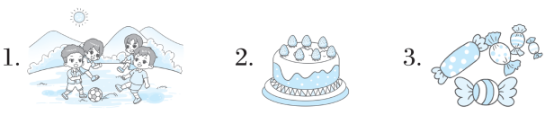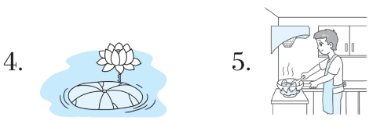
( ) 1. We are flying kites in the park.
( ) 2. —What kind of cake would you like?
—I’d like a fruit cake.
( ) 3. —Mum, can I have some jelly, please?
—Sure! I’ll buy some for you.
( ) 4. —Which season do you like best?
—I like summer best.
( ) 5. —What’s Mr Zhang’s hobby?
—His hobby is cooking meals.
- 选择恰当的选项，
A．Open the box and see.
B．My hobby is collecting stamps.
C．I have a new toy car.
D．They’re so colourful and beautiful.
E．Yes. I like collecting them.
补全对话。（10分）
Bob: Hi, Peter. 1
Peter: Can I have a look, please?
Bob: Sure! 2
Peter: Wow! What a super car!
Do you like toy cars?
Bob: 3 What’s your hobby,
Peter?
Peter: 4
Bob: How about you, Kate and Li Yan?
Kate: My hobby is collecting maps.
Li Yan: I like collecting picture cards. Look!
Bob & Peter: Oh! 5
九、阅读短文，选择正确的选项。（10分）
On Christmas Eve, the night before Christmas Day, children are very happy. They put their stockings at the end of their beds before they go to bed. They want Father Christmas to give them some presents.
Mr. Green tells his children that Father Christmas is a very kind man. He comes on Christmas Eve. He lands on top of each house and comes down the chimney（烟囱） into the fireplace and brings them a lot of presents.
Christmas Day always begins before breakfast. The children wake up very early. They can’t wait to open the presents in their stockings. Then they wake up their parents and call: “Merry Christmas!”
Do you know what Christmas means? Christmas Day is the birthday of Jesus Christ. When Christ was born, many people gave him presents. So today, people still do the same thing to each other.
( ) 1. Christmas Eve is ______.
A．Christmas Day B．the night of Christmas Day
C．the night before Christmas Day
( ) 2. Father Christmas often puts the presents ______.
A．into children’s hats B．into children’s stockings
C．under children’s beds
( ) 3. Father Christmas comes into the house through the ______.
A．window B．front door C．chimney
( ) 4. On the morning of Christmas Day, children wake up their parents very early and say “__!”
A．Good bye B．Happy New Year C．Merry Christmas
( ) 5. On Christmas Day, people often ______ to each other.
A．give presents B．ask for money C．give money
十、书面表达。（10分）
以My favourite season为题， 写一写你最喜欢的季节， 介绍这个季节中包含的月份和节日以及你在这个季节里可以做什么。
要求： 1. 字迹工整， 语法准确。2. 不少于五句话。
My favourite season
_______________________________________________________________________________________________________________________________________________________________________________________________________________________________________________________________________

